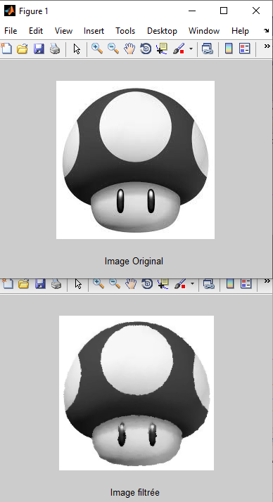

**FILTRE MEDIANE N°2 AVEC BRUIT P & S**

%----FILTRE MEDIAN 3x3 BRUIT P&S----

clc;

close all;

clear all;

I = imread('pic.bmp');

[U,V] = size(I);

d=uint8(sqrt(U*V*50/100)); %Affectation de l'image original 50%

figure(1);imshow(I);xlabel('Image Original');

%-------------BRUIT-------------

for i=1:d;

for j=1:d;

k= 255*(floor(rand(1,1)+1.5)-1);

I(uint16((U-1)*rand(1,1))+1,uint16((V-1)*rand(1,1))+1)=uint8(k);

end

end

%-------------------------------

f=5;

for i=1:U-f;

for j=1:V-f;

H=I(i:i+f-1,j:j+f-1);

HV = H(:);

HV=sort(HV);

Im(i,j)=HV(uint8((f^2+1)/2));

end;

end;

figure(2);imshow(Im);xlabel('Image filtrée');